Guide for using the School NSQF Program Counselling Pack

Objective: The Counselling Pack enables a consistent, quality and effective process of awareness amongst school students and their parents so that the deserving/appropriate students enroll into their choice of trade under NSQF School Program
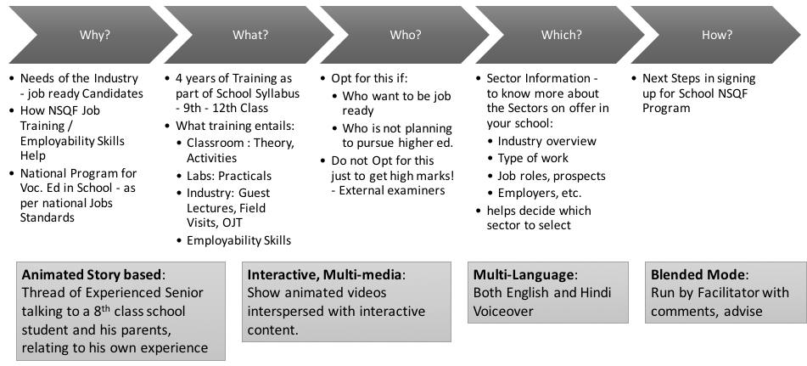

Users & Audience: The Vocational Trainer, along with the School Principal/ Coordinators would show it to the intended audience – students (and their parents) graduating/passing out from 8th standard or who have just joined 9th standard and are exploring to join NSQF program.

Requirements to run the counselling pack: A classroom/hall with computer/laptop, a projector and screen along with speaker (connected to computer)

Installation Process: Follow these simple steps to install package on laptop/computer:
- Login (if not registered, “Register”) on http://www.wfgsn.org
- Go to “Resources” on top menu and select “School Counselling Pack”
- Run the program by clicking “Run Aage Ki Soch” button
- NOTE: If you do not have internet access, you can download the counselling pack on your computer and run it from there without internet. Click on the “Click to Download” button. It will download a zip file called “GSN_Schools_Counseling_Pack.zip” on your computer. Unzip this file – it will open into a folder called “GSN_Schools_Counseling_Pack”, Go into that and start the program by double clicking “Aage Ki Soch” (or “Aage Ki Soch.exe”)
NOTE: For best results, please have latest version of browser installed on your computer

How to run Sessions: For best results, use the following process:
- Run the counselling pack slide by slide for all 9th standard students;
  - Pause at the end of each screen to explain anything not understood by students
  - For interactive screens, (e.g. who should opt for NSQF), stop and ask Students to suggest what to drag and drop or click, etc. This will get them to think.
  - At end of the session, please provide feedback online or in the provided form
- Ask interested students to talk to their parents and even bring them to school.
- When parents come, show them the same counselling tool and clarify their doubts
- Have final interested students sign up as per as the process in the school

